1) Consider the linked list shown in Figure below. Assume that the nodes are in the usual info-link form. If

necessary, declare additional variables.

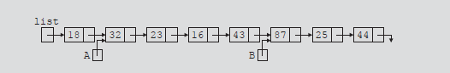

Write C++ statements to do the following:

a. Make A point to the node containing info 23.

b. Make list point to the node containing 16.

c. Make B point to the last node in the list.

d. Make list point to an empty list.

e. Set the value of the node containing 25 to 35.

f. Create and insert the node with info 10 after the node pointed to by A.

g. Delete the node with info 23. Also, deallocate the memory occupied by this node.

2) Show what is produced by the following C++ code. Assume the node is in the usual info-link form with the info of type int. (list and ptr are pointers of type nodeType.)

list = new nodeType;

list->info = 20;

ptr = new nodeType;

ptr->info = 28;

ptr->link = NULL;

list->link = ptr;

ptr = new nodeType;

ptr->info = 30;

ptr->link = list;

list = ptr;

ptr = new nodeType;

ptr->info = 42;

ptr->link = list->link;

list->link = ptr;

ptr = List;

while (ptr != NULL)

{

cout << ptr->info << endl;

ptr = ptr->link;

}